LED SEQUENCE v 3.0

# LAYERED ARCHITECTURE

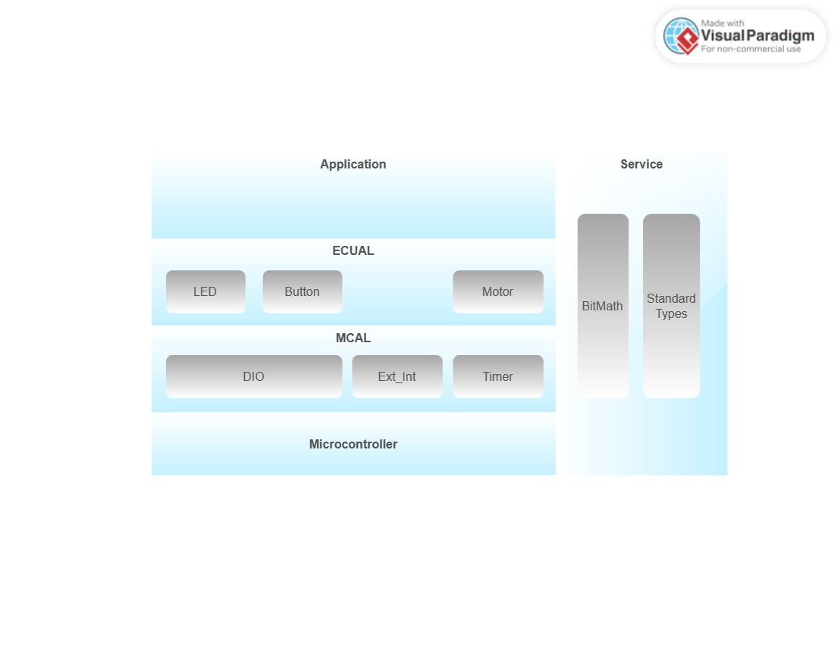MODULE AND PERIPHERALS DESCRIPTION

**DIO (Digital Input/Output):** This module deals with the digital input and output operations, such as reading and writing to digital pins of a microcontroller or a microprocessor. It may include functions for setting pin direction, reading and writing digital values, and handling interrupts related to digital pins.

**Motor:** This module is responsible for controlling the motors in the car, such as M1, M2, M3, and M4 as mentioned in the system requirements. It may include functions for setting motor speed, direction, and handling motor control signals.

**Button:** This module deals with the buttons in the system, such as PB1 and PB2 as mentioned in the system requirements. It may include functions for detecting button presses and handling button-related events.

**EXT_INT (External Interrupt):** This module handles external interrupts, which are signals from external sources that can trigger interrupts in the microcontroller or microprocessor. It may include functions for configuring and handling external interrupts from external devices, such as buttons or sensors.

**LED** he LED module is responsible for controlling the LEDs (LED1, LED2, LED3, LED4) mentioned in the system requirements. It may include functions for setting the LED states (e.g., ON or OFF), controlling LED brightness or color (if applicable), and handling any other operations related to LED control

**Timer:** This module deals with timer operations, such as configuring and handling timers in the microcontroller or microprocessor. It may include functions for setting timer intervals, handling timer interrupts, and measuring time. And This module deals with generating PWM signals using normal mode, which are used for controlling the intensity of an output signal, such as controlling the speed of motors or the brightness of LEDs. It may include functions for configuring and controlling PWM signals.

**BIT_MATH**: This module provides functions for performing bitwise operations, such as AND, OR, XOR, and shifting, which are commonly used for manipulating individual bits in registers or memory locations.

**Standard Types:** This module includes standard data types, such as integer types, floating-point types, and Boolean types, which are used for representing data in a standardized way across the system.

# API

## DIO

EN_dioError_t DIO_init(uint8_t portNumber, uint8_t pinNumber, uint8_t direction);

EN_dioError_t DIO_write(uint8_t portNumber, uint8_t pinNumber, uint8_t value);

EN_dioError_t DIO_toggle(uint8_t portNumber, uint8_t pinNumber);

EN_dioError_t DIO_read(uint8_t portNumber, uint8_t pinNumber, uint8_t *value);

## EXTERNAL INTERRUPTS

EN_extintError_t EXTINT_Init (uint8_t intNumber);

void EXTINT_setCallBackInt (uint8_t intNumber, void (*funPtr) (void));

## LED

EN_ledError_t LED_init(uint8_t ledPort,uint8_t ledPin);

EN_ledError_t LED_on(uint8_t ledPort,uint8_t ledPin);

EN_ledError_t LED_off(uint8_t ledPort,uint8_t ledPin);

EN_ledError_t LED_toggle(uint8_t ledPort,uint8_t ledPin);

## BUTTON

EN_buttonError_t BUTTON_init(uint8_t buttonPort, uint8_t buttonPin);

EN_buttonError_t BUTTON_read(uint8_t buttonPort, uint8_t buttonPin, uint8_t *buttonState);

## APP

void APP_initModules(void);

void APP_superLoop (void);

void APP_carMoveForward(void);

void APP_carTurnRight(void);

void APP_testingMotors(void);

void APP_sysTickTask(void);

void APP_carMoveRight(void);

void APP_carStop(void);

void APP_button1Task(void);

## TIMERS

en_timerError_t TIMER_init(u8 u8_a_timerUsed);

en_timerError_t TIMER_setTime(u8 u8_a_timerUsed, u32 u32_a_desiredTime);

en_timerError_t TIMER_start(u8 u8_a_timerUsed);

en_timerError_t TIMER_stop(u8 u8_a_timerUsed);

en_timerError_t TIMER_pwmGenerator(u8 u8_a_timerUsed, u32 u32_a_desiredDutyCycle);

void TIMER_setCallBack(u8 u8_a_timerUsed, void (*funPtr)(void));

en_timerError_t TIMER_stopInterrupt(u8 u8_a_timerUsed);

en_timerError_t TIMER_delay(u8 u8_a_timerUsed, u32 u32_a_timeInMS);

en_timerError_t TIMER_enableInterrupt(u8 u8_a_timerUsed);

# FUNCTIONS FLOWCHART

## DIO

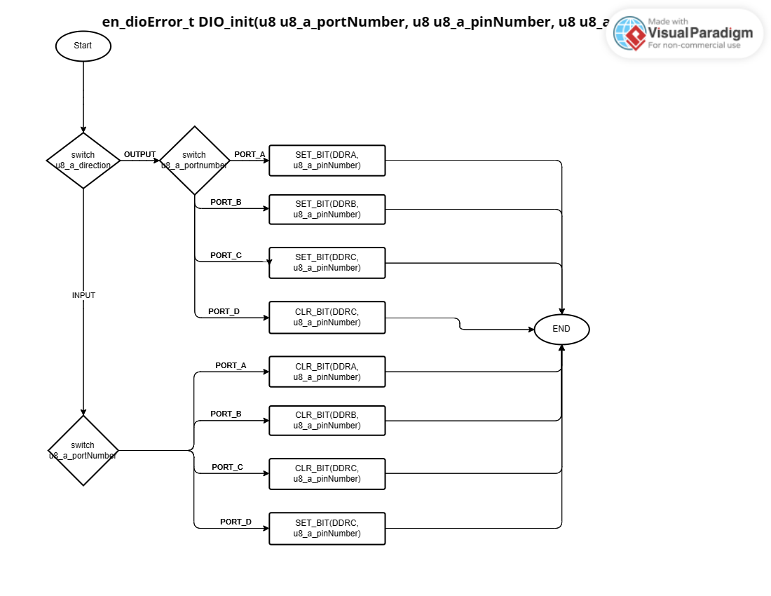

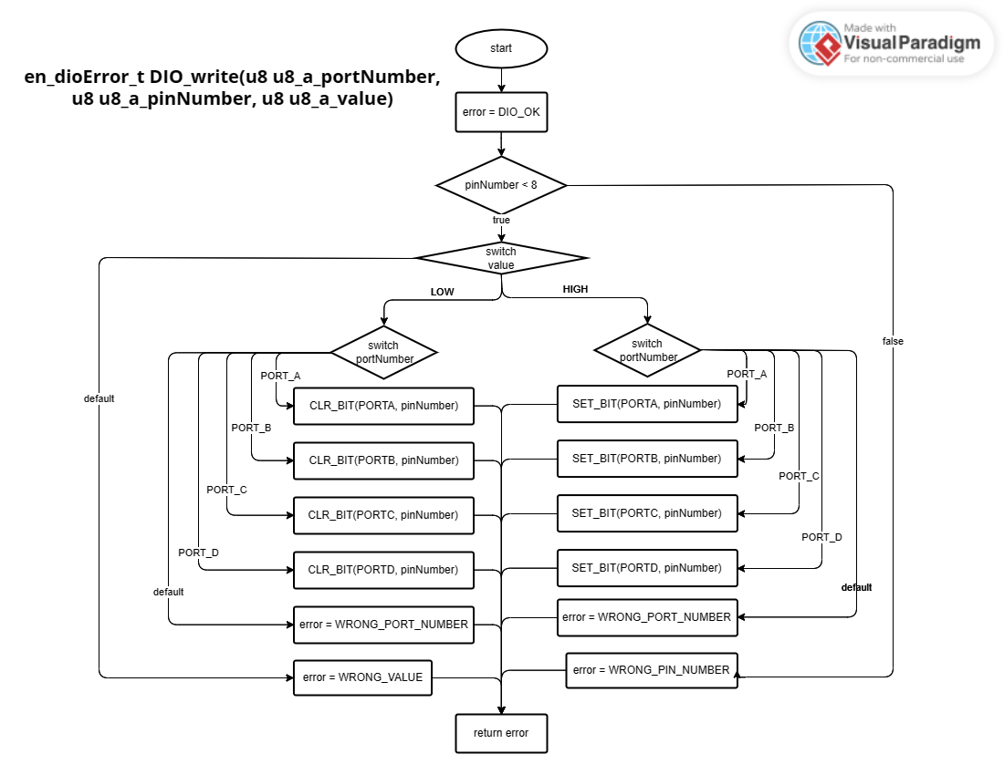

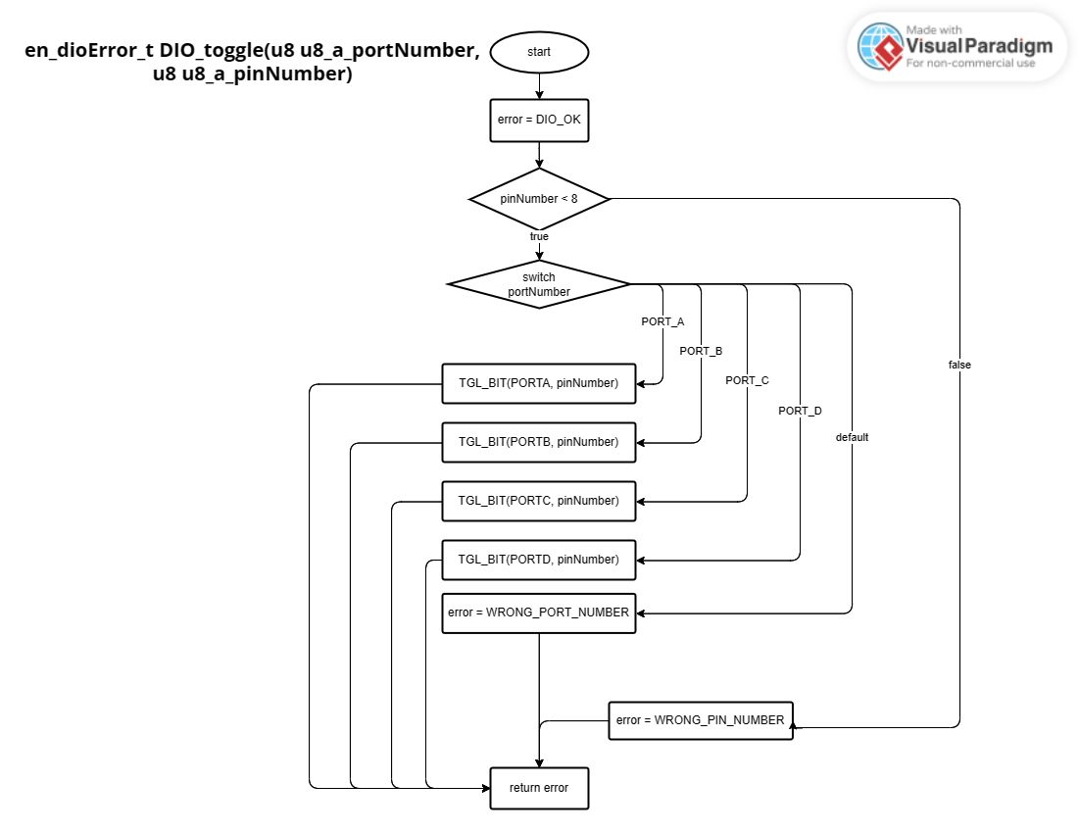

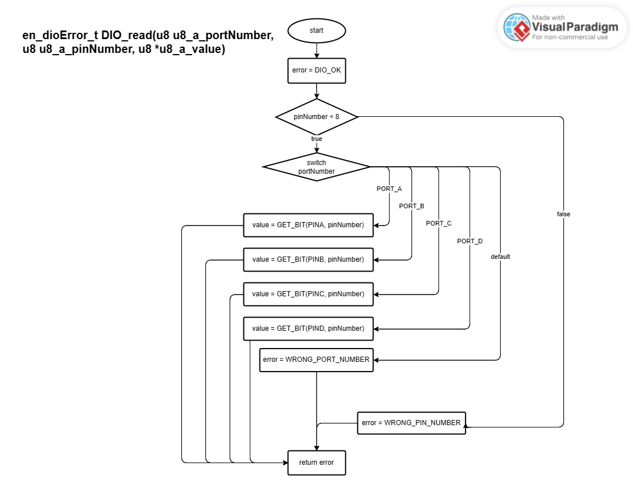

## 2.EXTERNAL INTERRUPTS

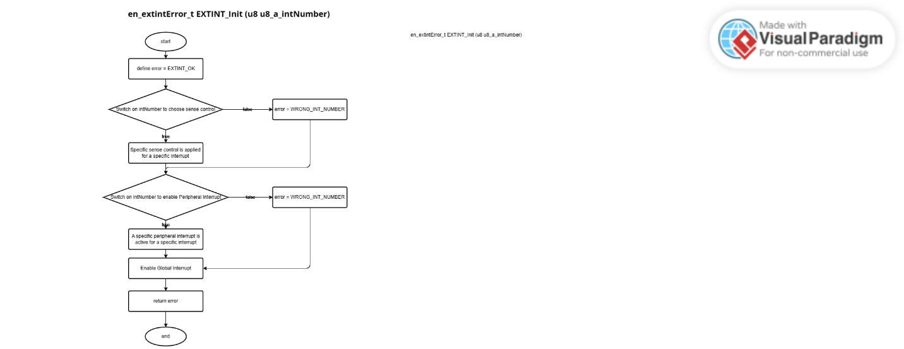

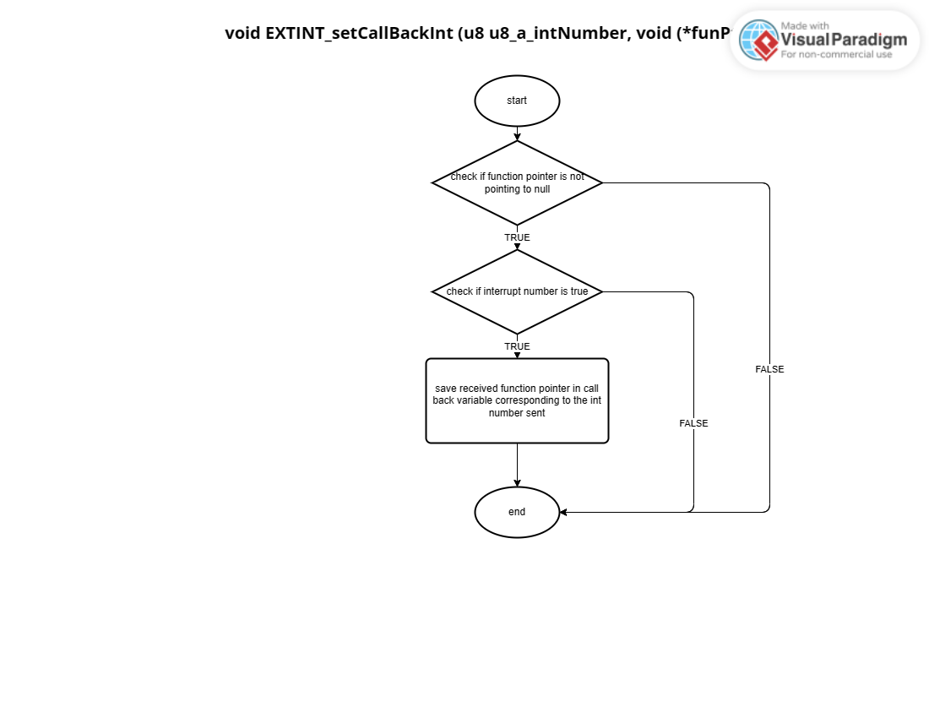

## 3.LED

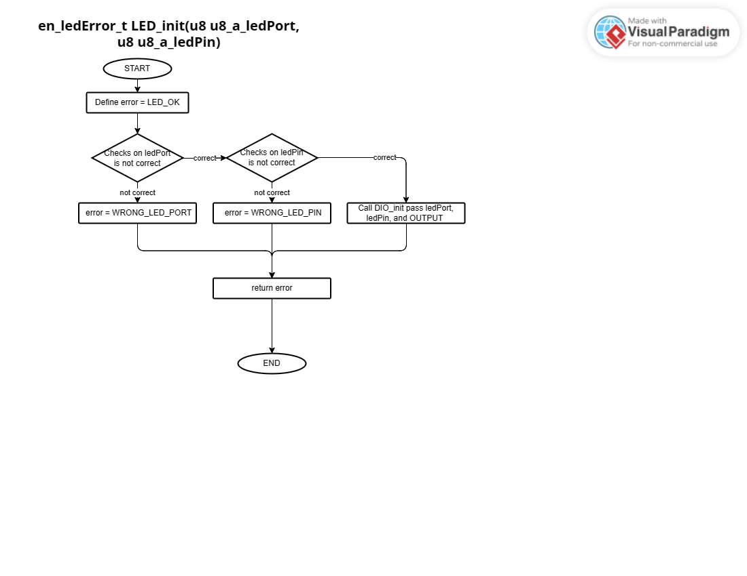

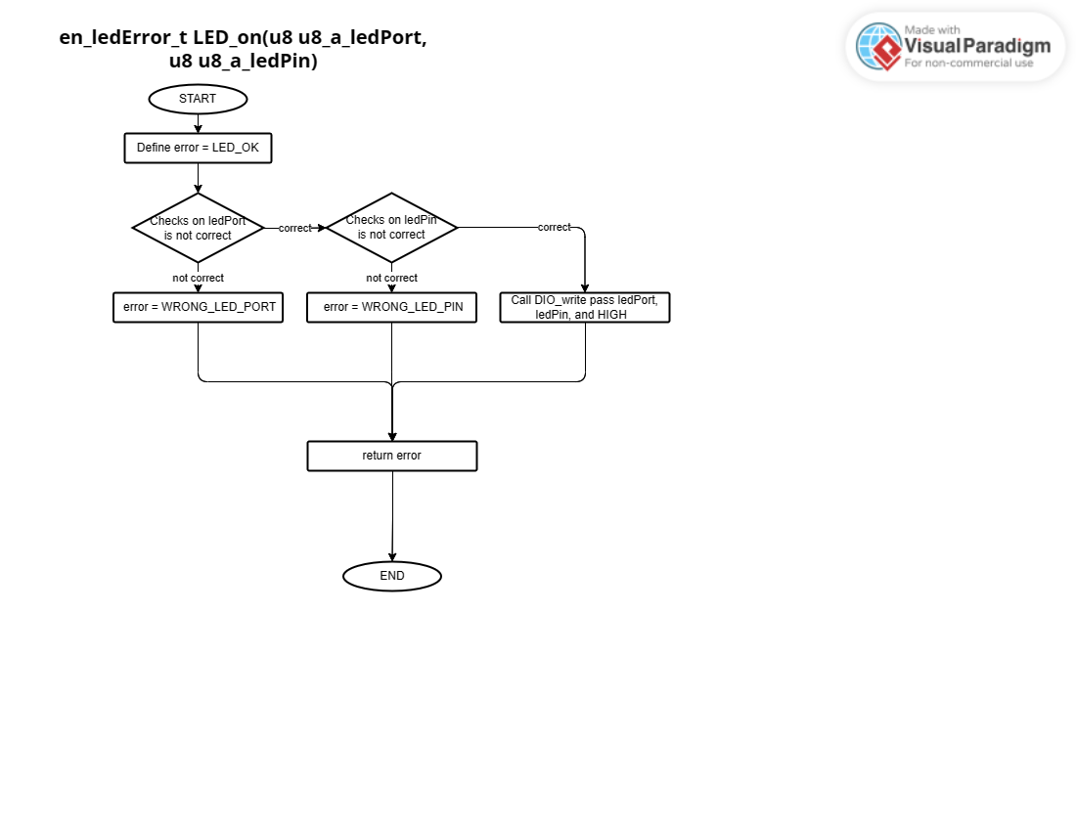

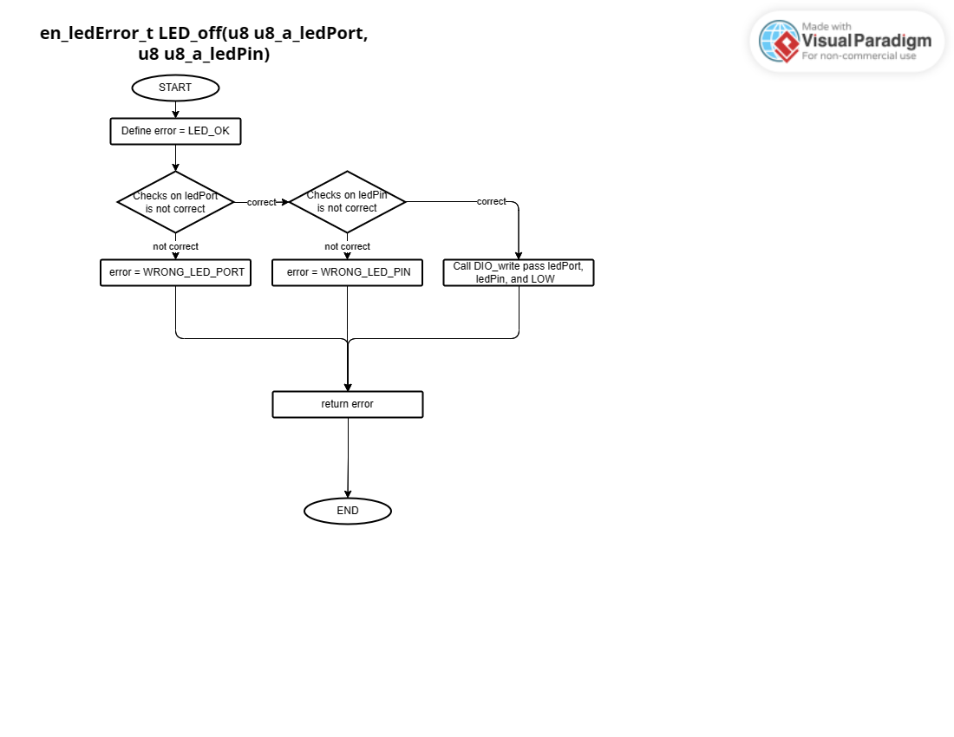

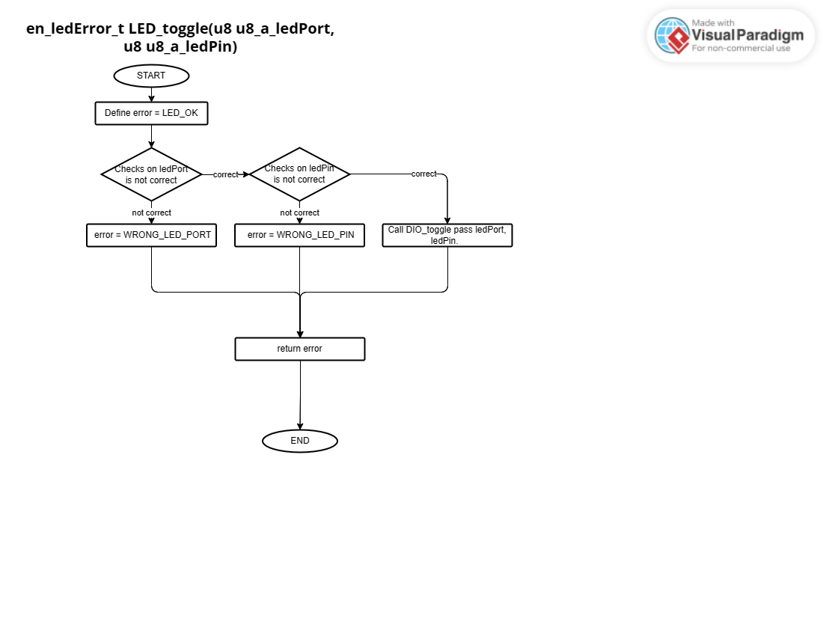

## 4.BUTTON

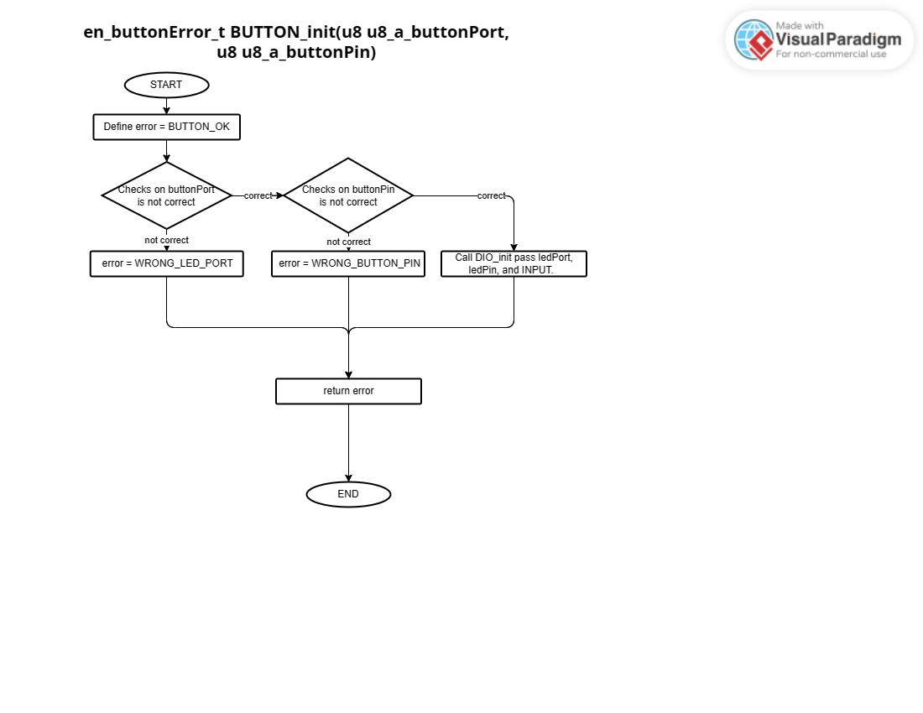

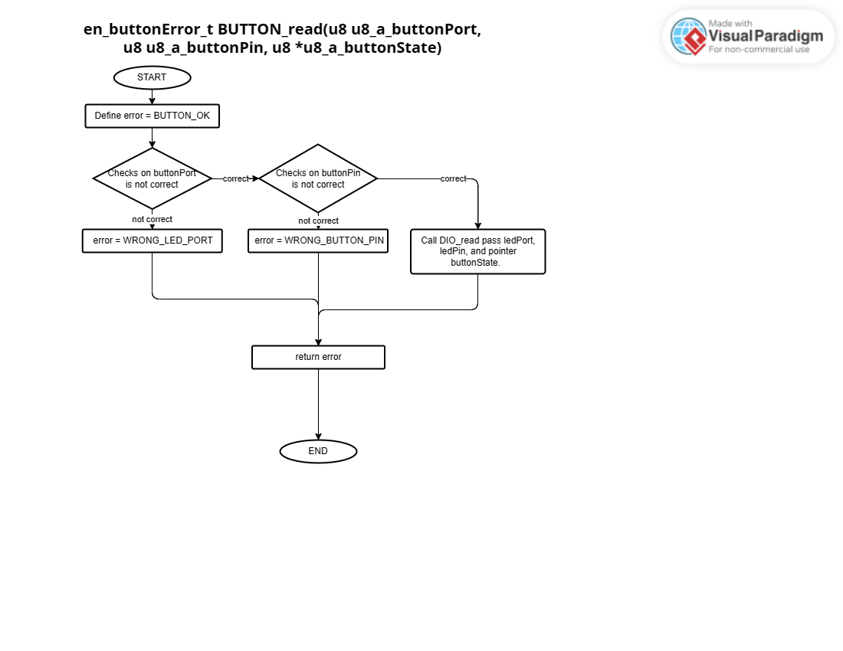

## 5.TIMERS

en_timerError_t TIMER_init(u8 u8_a_timerUsed);

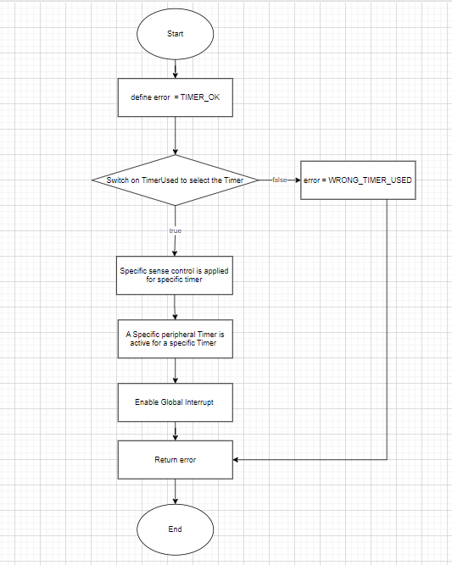

en_timerError_t TIMER_start(u8 u8_a_timerUsed);

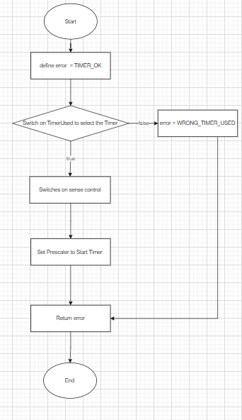

en_timerError_t TIMER_setTime(u8 u8_a_timerUsed, u32 u32_a_desiredTime);

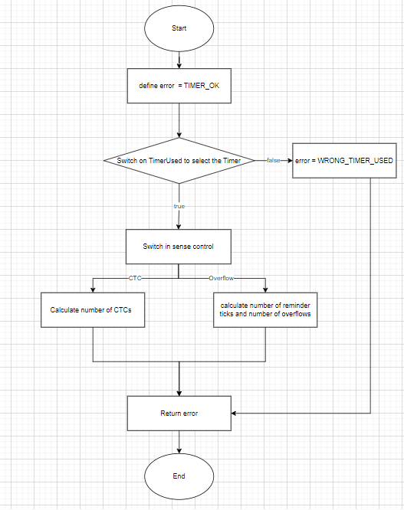

en_timerError_t TIMER_stop(u8 u8_a_timerUsed);

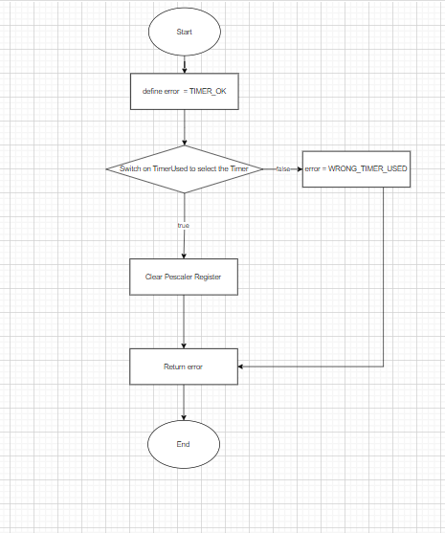

en_timerError_t TIMER_pwmGenerator(u8 u8_a_timerUsed, u32 u32_a_desiredDutyCycle);

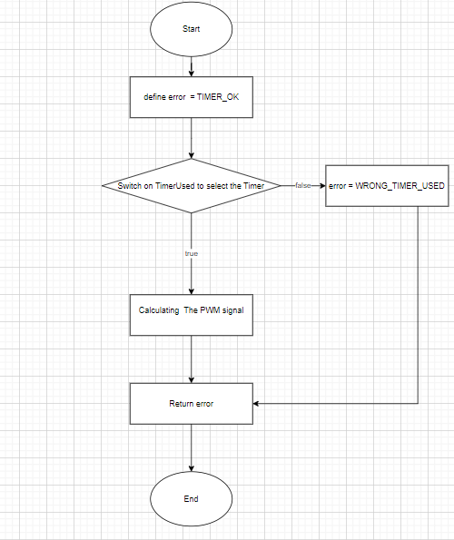

Void TIMER_setCallBack(u8 u8_a_timerUsed, void (*funPtr)(void));

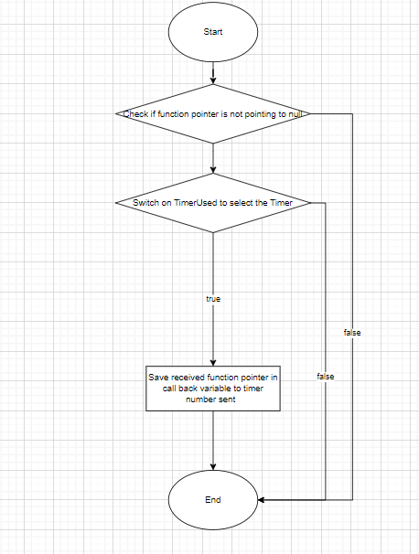

en_timerError_t TIMER_stopInterrupt(u8 u8_a_timerUsed);

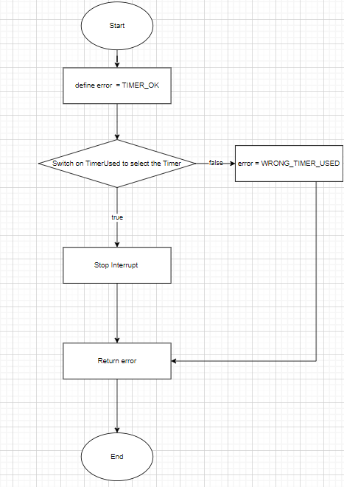

en_timerError_t TIMER_delay(u8 u8_a_timerUsed, u32 u32_a_timeInMS);

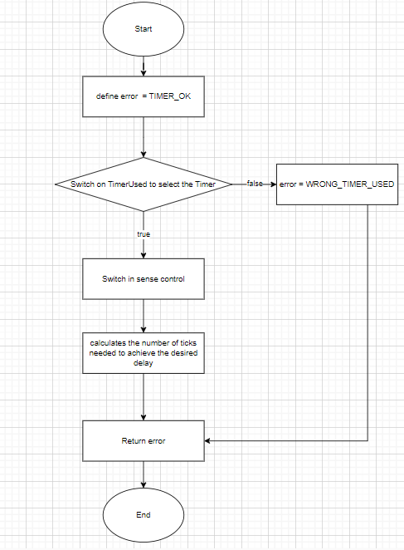

en_timerError_t TIMER_enableInterrupt(u8 u8_a_timerUsed);

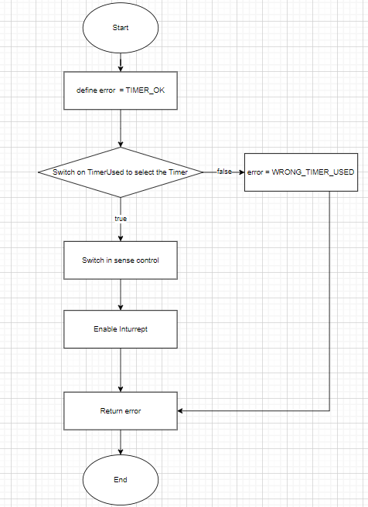

## 6.APP

